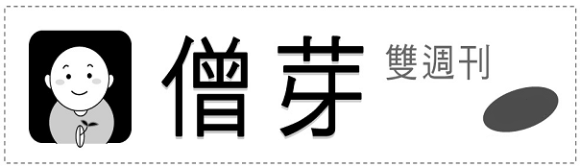
第二期
2009/01/21
……………………………………………………………………………………………..………...
本期資訊
留言板
●發行單位：法鼓山僧伽大學教務處 ●網頁:http://sanghau.ddm.org.tw ●電話：(02) 2498-7171#2351

【本期主題】 找到生命的價值
【智慧小語】 試著欣賞積極付出的自己，曾經努力過的， 無論結果是什麼，都不會白費，也都會很值得。
【與法相遇】 五蘊
【近期活動預告】 心光講堂演講、法鼓山2009年新春祈福法會
【歷屆考題】 96學年度佛學概論、97學年度英文

時代的年輕人不坊思考：時代因種種的因緣在改變，而您仍以不變應萬變嗎？

覺得未來有安全感嗎？老是這樣子好嗎？
那也請你想想:你自己可以為改變現狀盡一點力量嗎？怎麼做呢？

如果您想有一個明亮的未來…………

本期主題
找到生命的價值
經常有人向我訴苦，說他們自己這一生好像是白活了！不但經常是在胡思亂想之中，體會不到活在當下的自在；更嚴重的是，心裡常有一種悶悶的、被蒙蔽的感覺，每天活得麻木不仁、行尸走肉一般，找不到生命真正的價值！
要活出生命真正的價值，就要看我們怎麼使用生命；生命只要被使用，就會有價值。不過，價值有正面的，也有負面的。
在創造生命的價值，發揮生命的意義之前，先要瞭解構成生命價值的要素，基本有三種現象：第一是思想現象，第二是語言現象，第三是身體的活動現象。佛教將這三種現象稱之為「三業」：身體活動的行為叫做「身」，語言的行為叫做「口」，思想的行為就是「意」。生命的價值是正、是負，就要看我們如何運作這三種現象，怎樣使用這「三意」。
所謂「負面」的生命價值，就是在品德、人格方面成長得不夠，對飲食、男女等生存的物質需求與欲望較強，這是屬於動物本性的、獸性的表現；一旦這部分的欲望比較強，精神層次就不容易提昇。
至於「正面」的生命價值是什麼呢？就是具備且發揮了作為一個人應有的行為，包括：倫理道德、人際相處間的互助與尊重、理性與思想。尤其是第三項，人之所以可貴，就因為人是理性的，會思考，有思想。
老虎吃人，牠只要覺得想吃，就隨時隨地想辦法去吃，並不需要有什麼想法，只要牠想吃，牠是不會去考慮人能不能吃？雞能不能吃？如果人類沒有思想，做出來的事、說出來的話就很容易和動物一樣。
所有的動物裡，只有人有思想，為什麼不好好運用這種優點，讓自己的人生過得有意義呢？加強人之所以為人的部分，生命的正面價值就能夠呈現出來。
不妨靜下來看一看自己：「我的腦中所想的，是道德的，還是不道德的？是合理的，還是不合理的？是有用的，還是沒有用的？是實際的，還是不切實際的？」只要經常反省，便會發現：平常我們腦中所動的念頭，沒有用的比有用的多，不道德的比道德的多，負面的比正面的多。
但是，有些人會把心思用在另一方面，結果變成了心機。例如：明明心裡很生氣，已經在罵人、恨人了，但是嘴巴上不說出來，連臉上表情和行為上也不表現出來；或是原本想講什麼，在頭腦裡過濾後，為了自己利益，反而說出相反的話，讓別人都誤以為他是好人、是君子、是可靠的人，其實他心裡面想什麼，沒有人知道。
如果思想是用在這個方面，那也不好。我們不是要在表面上做個好人，做個君子就夠了，最重要的還是要體察我們的內心，改變我們的內心，才能夠真正發現生命的意義，發揮生命的價值。

-----摘自＜找回自己＞

智慧小語

試著欣賞積極付出的自己，曾經努力過的，
無論結果是什麼，都不會白費，也都會很值得。
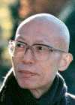

與法相遇

五蘊：色蘊、受蘊、想蘊、行蘊、識蘊
The Five Skandhas：Of the five skandhas, only form is part of the physical realm. The remaioning four—sensation, perception, volition, and consciousness—make up the mental realm.
什麼是「五蘊」呢？簡單的說，五蘊就是：色蘊、受蘊、想蘊、行蘊、識蘊，是吾人身心的總合。色蘊是指生理的、物質的現象，受、想、行、識四蘊是指心理的、精神的活動。
中文摘自《《心經》之二〈心經講記〉p26-27》
近期活動預告
1. 心光講堂：勇敢迎接改變
【演講貴賓】：褚士瑩
【活動時間】：2009/2/28 19：00～20：30（18：30開放入場）
【活動地點】：聯經文化天地 台北市忠孝東路四段561號B1
【洽詢電話】：02-28933161轉分機547或556，手機0963-370-393
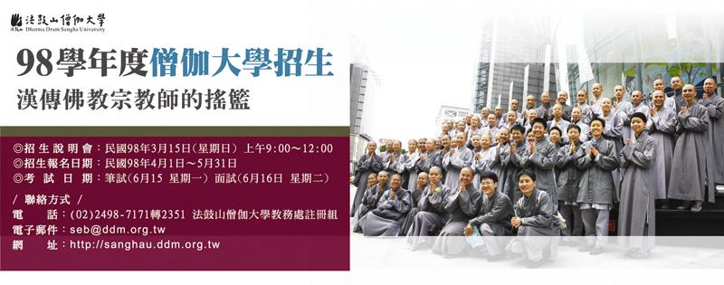
2. 心安平安迎福年：法鼓山2009年新春活動—祈福法會
新春期間有一系列的法會，除了來走春，也為全球消災祈福。用誠敬的懺悔心、感恩心來除舊，用恭敬的發願和回向來布新。
【舉行日期】：1/25（除夕19：30-21：00）
1/26～1/30（初一～初五祈福法會，詳情請洽知客處）
【活動地點】：大殿（第一大樓六樓）

96學年度佛學概論科試題
歷屆考題
一、簡答題：
      - 何謂三寶？
      - 何謂四聖諦？
      - 何謂四大？
      - 何謂六度？
      - 十二因緣的項目是什麼？
      - 佛成道的地方是哪裡？
      - 佛在何處初轉法輪
      - 佛教在什麼朝代傳入中國？

二、申論題：
1. 請描述釋迦牟尼佛傳
- 請談論在家修行與出家修行有何異同？
- 請申論解脫道與菩薩道如何互相配合？

97學年度英文科試題

一、詞彙：作題說明：請參照例題，於下表中選取適當的單詞，填入答案卷各題空格中。
attitude | liberation | process
bodhi-mind | motivation | reject
consequences | patience | remind
depends | pleasure | speech
easier | positive | tasting
future | practice | transformation
killing | precious | vows
例題：Bodhi-mind is the aspiration to enlightenment on the Mahayana path.

- One of the ten negative acts we should avoid is _____.
- Emotional afflictions lead to actions of body, _____ and mind.
- When one hates something, he or she tries to _____ or escape it.
- Emptiness, no-form and no-vow are called three gates of _____.
- Practitioners on the bodhisattva path should try to develop a selfless _____.
- It is not the action, but the _____ behind the action, that is more important.
- Not clinging to either the negative or the _____ is correct Buddhadharma.
- The Heart Sutra is much shorter than the Diamond Sutra, making it _____ to memorize.
- Whether physical pain leads to suffering _____ on your perspective and state of mind.
- The path to buddhahood must begin with _____; otherwise there would be no clear direction.
- In our practice we are concerned with _____. We do not focus on beginnings and ends.
- For a bodhisattva, the safest course is to constantly _____ oneself of the initial aspiration to bodhi-mind.
- We can also think about birth and death as _____—one phenomenon changing into another.
- The first five consciousnesses derive from our sense faculties of seeing, hearing, smelling, _____, and touching.
- Most people think only pain causes suffering; they seldom think that _____ also causes suffering.
- Many causes come together under various conditions (conditioned arising) to produce _____ (karmic results).
- A human body is difficult to obtain, so we should look upon our body as a _____ vehicle to practice contemplation.
- The twelve links of conditioned arising include past, present, and _____ lives, with each link arising out of the previous link.
- To a Buddhist practitioner, without the presence, guidance, and real _____ of wisdom, the Dharma would be no more than philosophy.
- Mahayana Buddhism speaks of perfection (paramita) in six aspects, including generosity, precepts, _____, diligence, concentration, and wisdom.

二、綜合測驗：作題說明：請依文意選出最適當的一個選項，填入答案卷各題空格中。
Great bodhisattvas do not think they have anything specific to accomplish. They do not have the idea 1 they must help sentient beings; rather, they naturally respond to others, 2 needs provide them 3 the opportunity to practice. Far from 4 gratitude, they are thankful to others. This is not humility, 5 the bodhisattva’s compassionate interaction with other beings. It is also the spirit of a Chan practitioner.
1. (A) that (B) how (C) what (D) which
2. (A) who (B) their (C) whose (D) whether
3. (A) about (B) for (C) to (D) with
4. (A) expect (B) expecting (C) expectation (D) expected
5. (A) and (B) but (C) for (D) or

Many people think they can help others only 6 they have solved their own problems. If you are starving, you may want to feed yourself first 7 help feed others. But this is 8 what is meant by the “beneficent practice of bodhisattvas.” Bodhisattvas help sentient beings not only materially 9 spiritually and mentally, for all hardships ultimately 10 our views of self, others, and the world. Therefore, one aspect of the bodhisattva way is to help others build right understanding.
6. (A) after (B) before (C) though (D) until
7. (A) in order to (B) instead of (C) just as (D) so that
8. (A) as far as (B) in fact (C) not necessarily (D) the same as
9. (A) as well as (B) but also (C) rather than (D) together with
10. (A) give rise to (B) let go of (C) originate from (D) stand for

三、翻譯：作題說明：請將以下兩段英文譯成正確、通順、達意的中文，並將答案寫在答案卷。請依序作答，並標明題號。
- The method of contemplating action is simple. Whenever your mind moves, be aware of your thoughts. Try not to act on non-virtuous, unwholesome thoughts. When they arise, do not reject or deny them. Just being aware of them is usually enough to make them gradually disappear.
- If we contemplate the causes of suffering, we will see that suffering does not come without cause, and that the cause of suffering is not outside, but within ourselves. Truly knowing this will reduce suffering. We also know that certain negative actions will lead to certain negative consequences. Hence, to avoid suffering, we must first recognize and refrain from such acts.

四、作文：
作題說明：請以 ”The Best Advice I Have Learned from There Is No Suffering: A Commentary on the Heart Sutra” 為題目，在答案卷上寫一篇200 ~ 300字左右的英文作文。

